(A Manufacturer) A manufacturer can sell chairs at a profit of $20 per unit and desks at a profit of $40 per unit. Three units of raw material are needed to manufacture one unit of chair, and six units of raw material are needed to manufacture one unit of desk. A total of 15,000 units of raw material are available. If any chair is produced, a setup cost of $20,000 is incurred; if any desk is produced, a setup cost of $35,000 is incurred. Determine how to maximize the manufacturer’s profit.

**Discussion: -**

Our objective is to maximize the profit. To calculate the Revenue, we must know the units produced, which will be one of the decision variables. To calculate the cost, we need to decide on the types of product produced. Below picture gives us one type of approach to solve this problem. We must decide to manufacture the products (Yes/No). Next step will be deciding on units produced and these parameters will help us in calculating the Revenue and cost values.

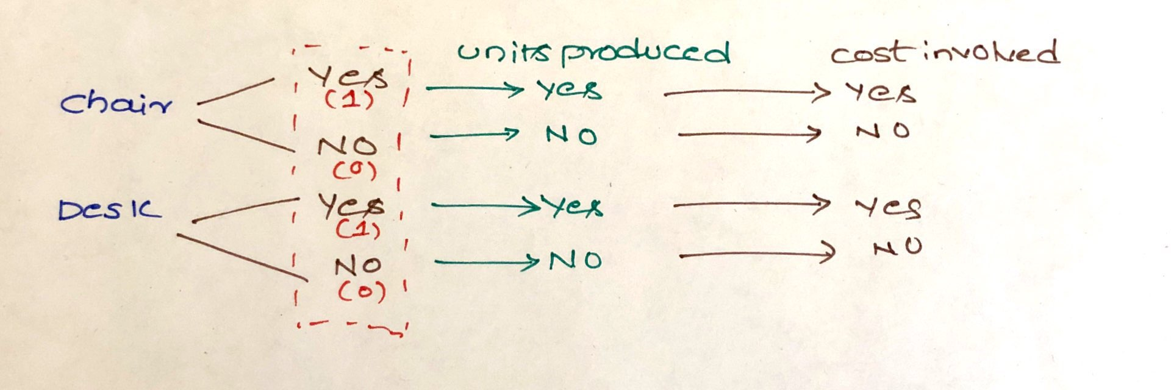

**Mathematical Model: -**

*Parameters (Inputs):*

$$i ϵ 1,2 \left( i: Index for products\right)$$

$R_{i} : Revenue from one unit of product i$

$$M_{i} : Units of material used to produce product i$$

$$C_{i} : Setup cost to produce product i$$

$$M : Max available raw material;M=15000$$

*Decision Variables:*

$$x_{i} :Decision on whether producing product i or not$$

$$y_{i} :Units of item i produced$$

*Objective:*

$$Maximize total profit=\sum_{i=1}^{2}{\left(y_{i}*R_{i}\right)}-\sum_{i=1}^{2}{\left(x_{i}*C_{i}\right)}$$

*Constraints:*

$$\sum_{i=1}^{2}{\left(y_{i}*M_{i}\right)}≤M ; \left(1\right) Raw Material Constraint$$

$$x_{i}ϵ\left\{0,1\right\} \left(2\right) Binary Constraint$$

$$y_{i}≤ A* x_{i} ;For i ϵ \{1,2\} \left(3\right) Production Constraint where A=5000$$

$$Where A is the maximum number of units that can be produced with the available raw material.$$

*Excel Implementation:* Please find the attached spreadsheet for solution.

 